MicroPython OOP Pi Pico Mini Project

Research and planning

This consists of the diagrams, including UML class diagram, dfd, flowchart, wiring diagram

**UML Class Diagram**

**Data Flow Diagrams**

Data flow diagram 0:

Data flow diagram 1:

Flowchart

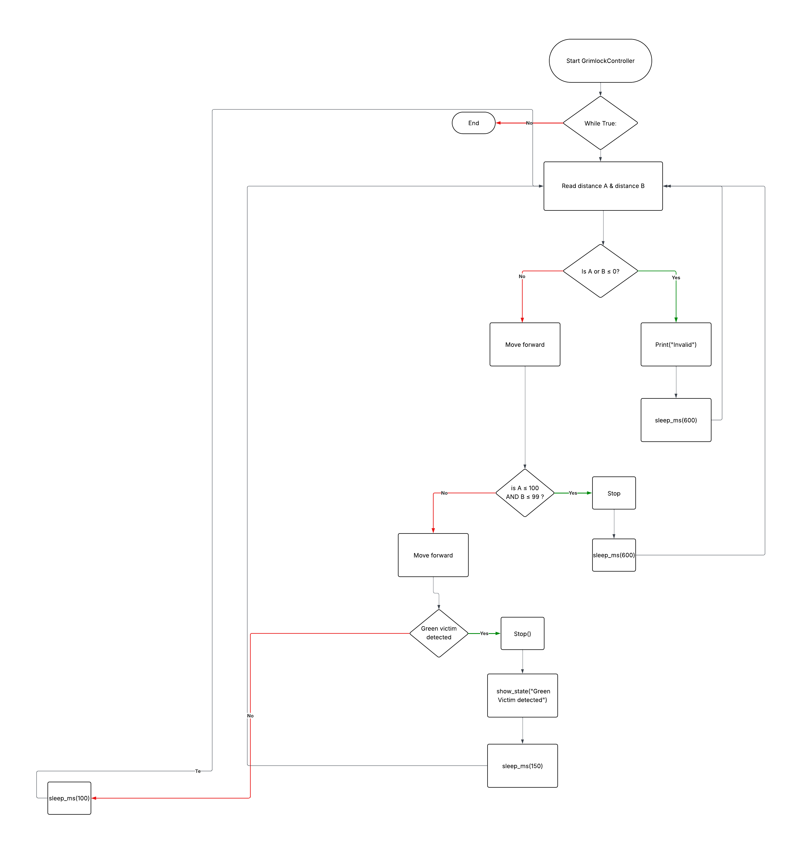

Wiring diagram:

Material components list

* 2x Servo Wheels
* Arduino Uno
* HC-SR04 Ultrasonic Sensor
* 5 Channel Digital Line Finder or 1 or more Digital/Analog Line Finder
* Dupont Cables
* 2x 3.7v 18650 Polymer Lithium Ion Battery
* 2x LiPo holder
* XL4015 DC to DC Converter Module (alternative to use Diodes in series)
* 5x20 PCB Fuse holder
* 5x20 fuse
* 2x 100µF 25v capacitors
* Wood
* 4x male to male wires
* 4x male to female wires

**Power supply calculations**

**Online simulations**